PRACTICAL NO 1

AIM : To install Selenium IDE in web browser.

Step 1: Open a browser (Firefox, Edge)
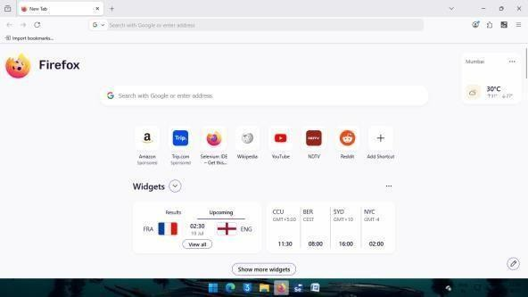
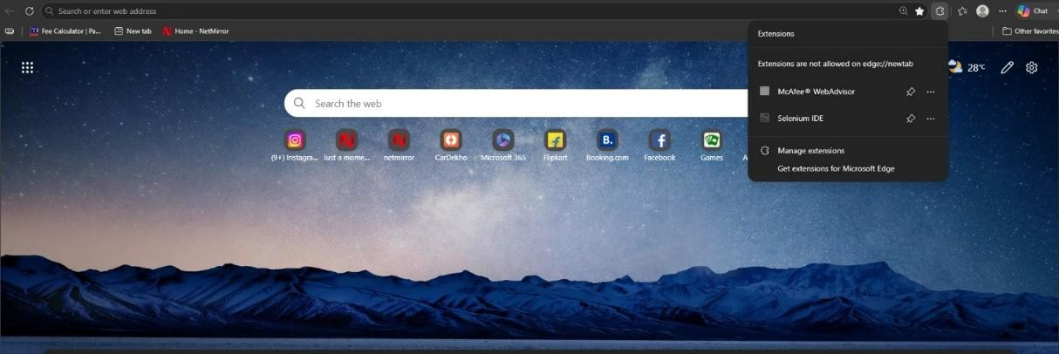

Step 2: Go to the right-hand corner. Step 3: Click on Extensions & Themes.
Step 4: In the search bar, type Selenium IDE. Step 5: Click on the Selenium IDE icon.

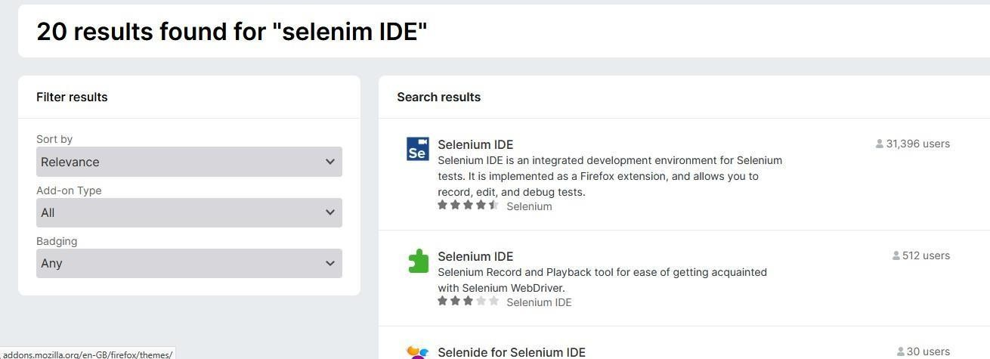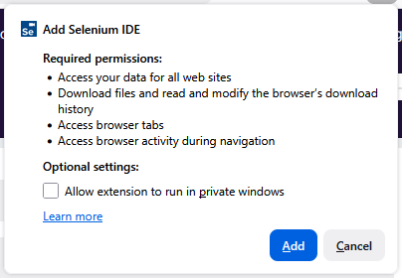
Step 6: Click Add to Firefox Step 7: Click on Add to continue
Step 8: We can see Selenium IDE was added.
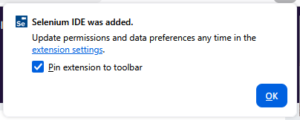

Step 8: We can see Selenium IDE was added. Step 9: Click OK to continue.

Conclusion:
This practical helped us understand how to install and configure Selenium IDE as a browser extension. We learned the initial setup required for web automation testing and became familiar with the Selenium IDE interface, which is the first step toward creating and executing automated test cases.

PRACTICAL NO 2

AIM : To test demo website in Selenium IDE

Note : Perform in Firefox
Step-1: Open web browser.
Step-2: Go to Selenium IDE extension. Step-3: Click on Selenium IDE.
Step-4: Go to Create a New Project.
Step-5: Give project name as "demotest", click OK to continue. Step-6: Paste a particular URL in the Selenium IDE.
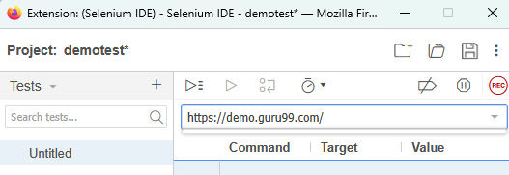
Step-7: Click on Record.

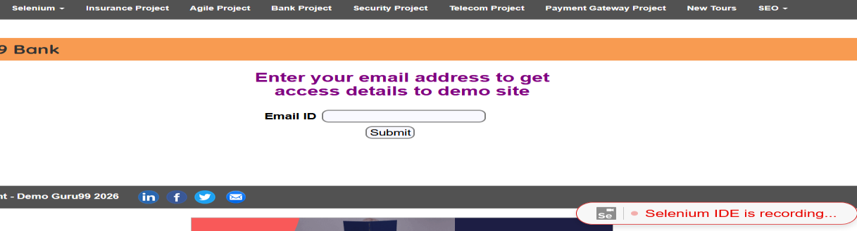
Step-8: Selenium IDE will start recording.

Step-9: Right-click on any blank space on the web page. Step-10: Go to Selenium IDE.
Step-11: Go to Assert.
Step-12: Go to Title and click.
Step-13: Come back again to Selenium IDE and stop recording. Step-14: Give a test name as DemoTitle, click OK to continue. Step-15: Click on DemoTitle
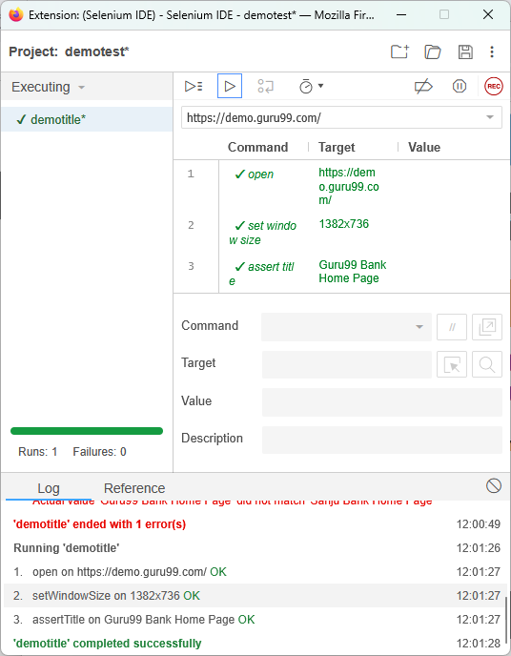

Conclusion:
This practical helped us learn the basics of automated web testing using Selenium IDE. We understood how to create a project, record user actions, use assertions (such as verifying the page title), save test cases, and execute them. This practical introduced us to the concept of validating web application behavior through automation instead of manual testing.

PRACTICAL NO 3

AIM : To test login demo website in Selenium IDE

Note : Perform in Edge
Step-1: Open the web browser.
Step-2: Open the Selenium IDE extension. Step-3: Click on Selenium IDE.
Step-4: Create a New Project.
Step-5: Give the project name as "LoginDemoTest" and click OK.
Step-6: Enter the demo website URL in Selenium IDE and click Start Recording.
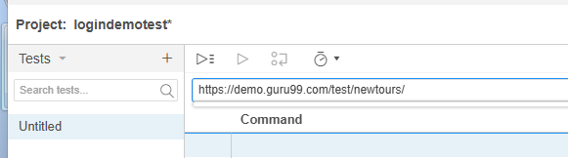
Step-7: On the login page, click on the Username field. Step-8: Enter the valid username.
Step-9: Click on the Password field. Step-10: Enter the valid password. Step-11: Click on the Submit button
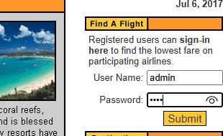

Step-12: Return to Selenium IDE and click Stop Recording.
Step-13: Save the test with the name LoginDemoTest and click OK.
Step-14: Click on the type option, once the information shows, change the name from admin to any other name,
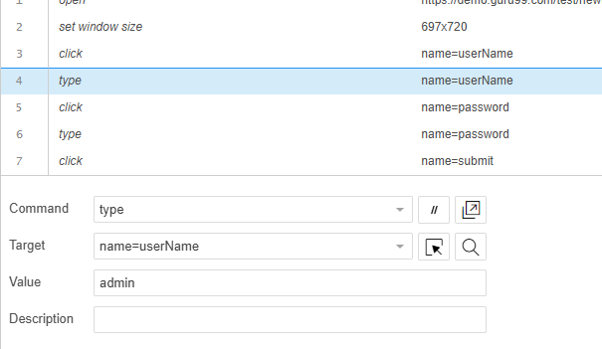
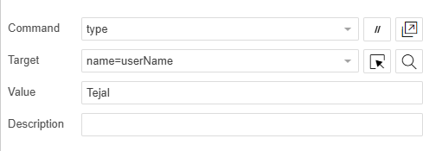
Step-15: Select LoginDemoTest from the project. Step-15: Click on Run Current Test.
Step-16: Verify that the test passes successfully without any errors.
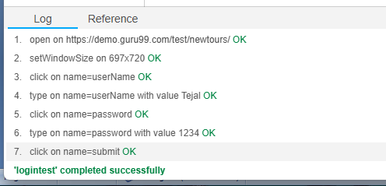

Conclusion:

- This practical helped us understand how to automate the testing of a login functionality using Selenium IDE.
- We learned to record user interactions, enter input into form fields, modify test data, execute the test case, and verify whether the login process behaves as expected.

- This demonstrated the importance of automated functional testing for validating user authentication and improving software quality.

PRACTICAL NO 4
AIM: To create a test suite containing a minimum of 4 test cases to validate different web page formats (HTML page, XML response, JSON API output, and a dynamic form page), execute the test suite, and generate the report.

Step 1: Open Selenium IDE
- Open Microsoft Edge.
- Click on the Selenium IDE extension.
- Create a project named WebPage Validation.

Step 2: Create Test Case 1 – Validate HTML Page
- Click + New Test.
- Name the test Validate an HTML Page.
- Enter the base URL:https://example.com/
- Record the required actions such as open, click, type, and assertText/assertTitle.
- Save the test case
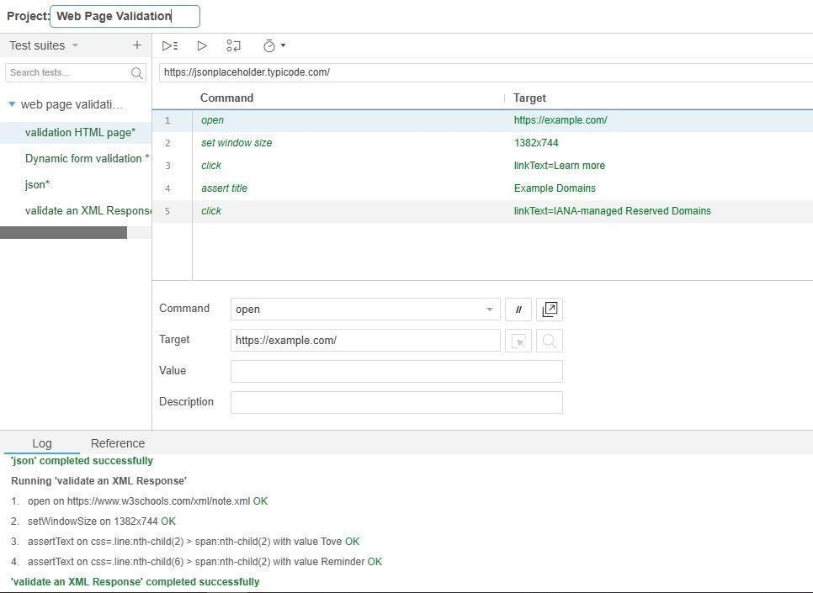

Step 3: Create Test Case 2 – Validate XML Response
- Create another test named Validate an XML Response.
- Open the URL: https://www.w3schools.com/xml/note.xml

- Add commands like open, assertText, and verifyText.
- Save the test case.
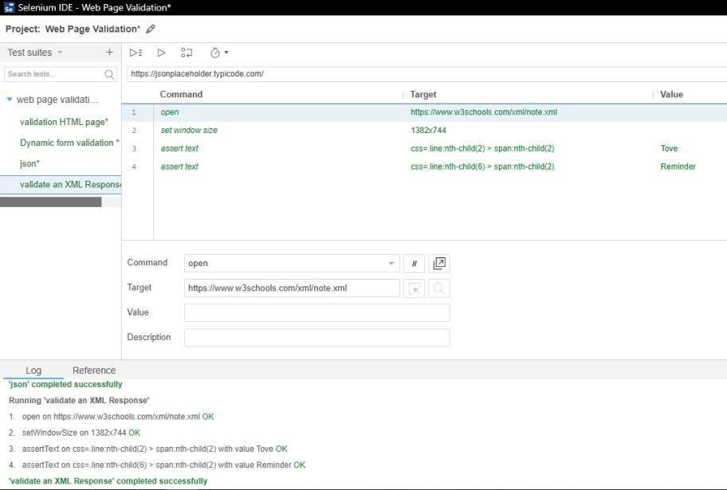
Step 4: Create Test Case 3 – Validate JSON API Output
- Create a new test named JSON Validation.
- Open the URL: https://jsonplaceholder.typicode.com/t
- Add the commands open, assertText, and verifyText.
- Save the test case.
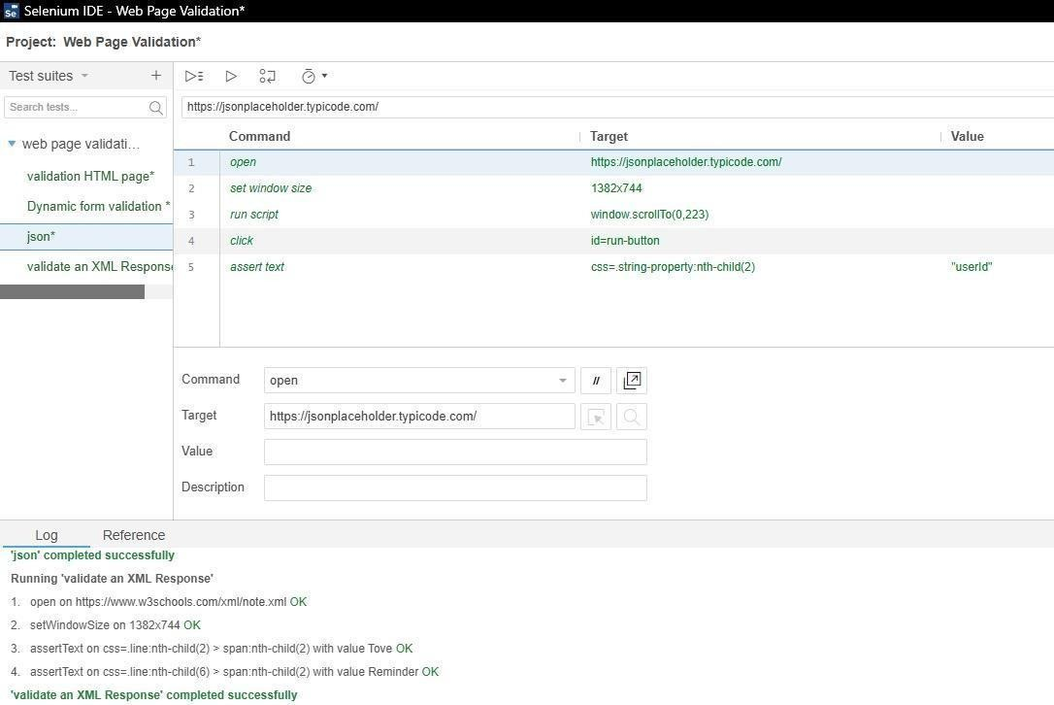

Step 5: Create Test Case 4 – Validate Dynamic Form
- Create a new test named Dynamic Form Validation.

- Open:https://www.selenium.dev/selenium/web/web-form.html
- Record actions such as entering text, selecting a dropdown option, clicking a checkbox, and submitting the form
- Add assertions to verify successful submission.
- . Save the test case.
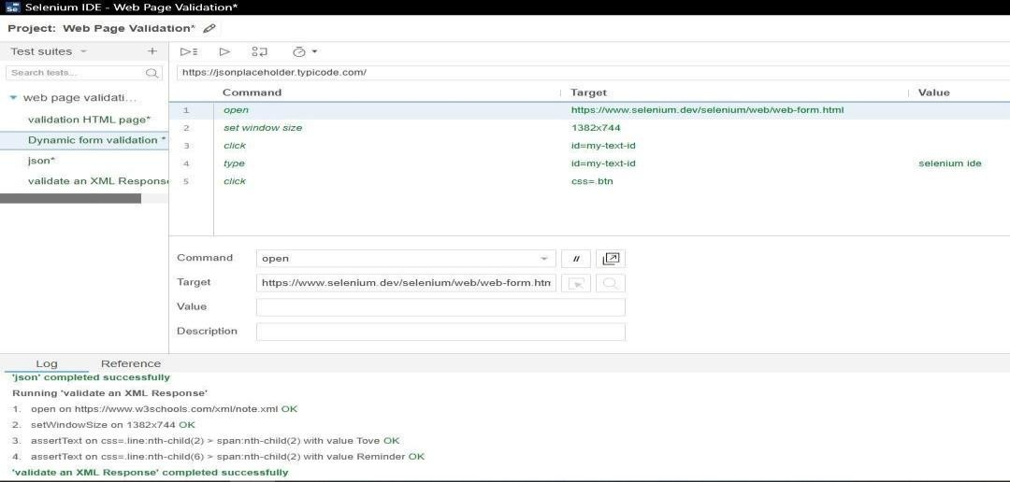

Step 6: Execute the Test Suite
- Select the WebPage Validation Suite project.
- Click the Run All Tests (▶) button.
- Observe the execution of all four test cases.
Step 7: Verify the Results
- Check the Log section.
- Ensure all commands show OK.
- Verify that all test cases are Passed.

Step 8: Display the Report
- View the execution results in the Log/Results panel.
- Note the Passed, Failed, and Execution Status of the test suite.
- Capture a screenshot of the successful execution report.

Conclusion:

  - This practical helped us understand the fundamentals of web application testing and test automation using Selenium IDE.
  - We learned how to create and organize multiple test cases into a test suite, automate browser interactions, validate different web page formats (HTML, XML, JSON, and Dynamic web forms), use assertions to verify expected results, and execute all test cases together. We also learned how to analyze execution logs and test reports to identify the success or failure of test cases.
  - These skills are essential for software testing, quality assurance (QA), and ensuring the reliability of web applications in real-world software development.

PRACTICAL NO 5
AIM : TO PERFORM CROSS-WEBSITE FUNCTIONAL TESTING USING SELENIUM IDE PROCEDURE:
PREREQUISITES REQUIRE FOR PRACTICALS ARE MENTIONED BELOW

1 MICRO EDGE WEB BROWSER SELENIUM IDE WEB EXTENSION 2 DIFF OPEN SOURCE WEBSITES TO TEST MULTIPLE TESTCASES ACC.

Step 1: Open Selenium IDE

- Launch Microsoft Edge.
- Open the Selenium IDE extension.
- Open the existing project or create a new project for cross-website functional testing.

Step 2: Record/Create Test Cases Test Case 1: Fill Form & Case 2: Fill Form
- Open https://demoqa.com/automation-practice-form.
- Set the browser window size.
- Enter the First Name.
- Enter the Last Name.
- Enter the Email Address.
- Select the Gender.
- Enter the Mobile Number.
- Enter the Subject (Maths).
- Select the required Hobby.
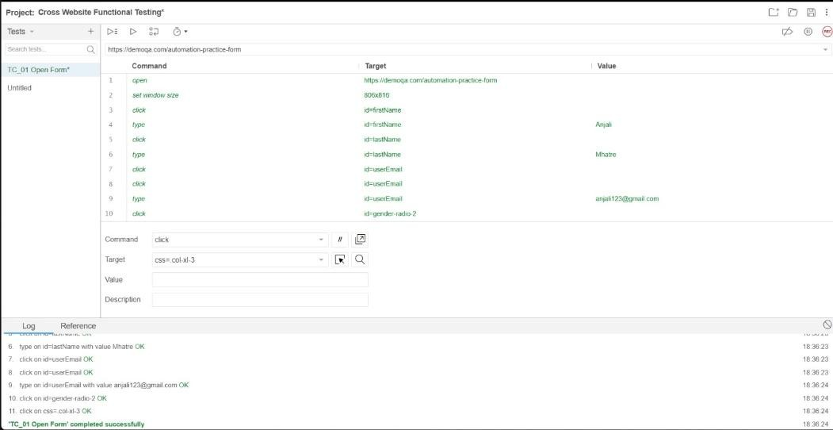
- Save the test case as TC02_FILLFORM. Test Case 1: TC_01 OPEN FORM

Test Case 2: TC_02 FILL FORM
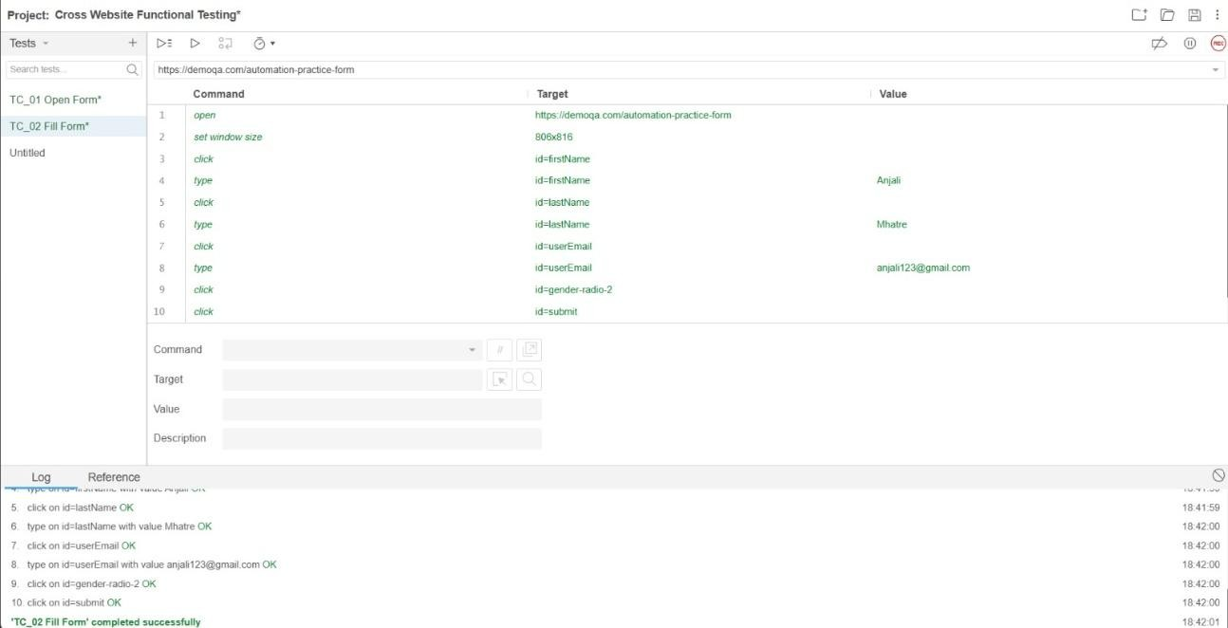

Case 3: Select Date of Birth (DemoQA)
- Open the DemoQA Practice Form.
- Click the Date of Birth field.
- Select the required Month.
- Select the required Year.
- Select the desired Date.
- Save the test case as TC03_SELECTDATE.

Test Case 3: TC_03 SELECT DATE OF BIRTH
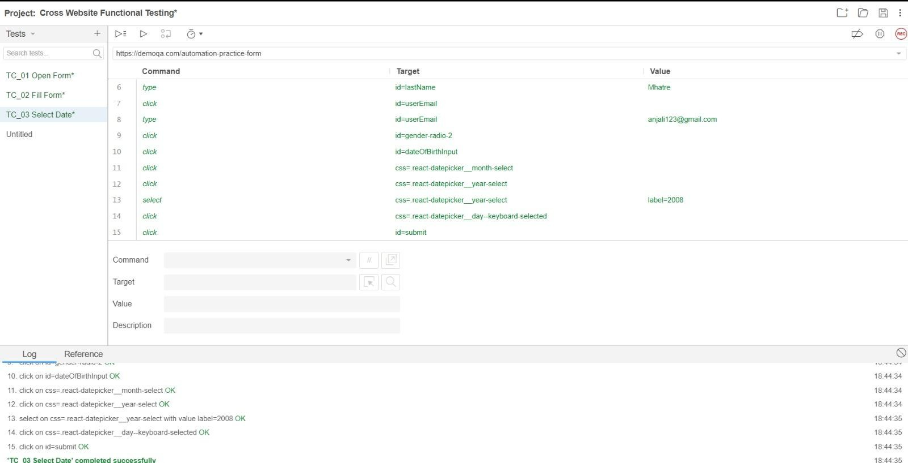

Case 4: SUBMIT FORM (DEMO QA)

- Select a Hobby.
- Click the Submit button.
- Verify that the submission dialog appears.
- Close the confirmation dialog.
- Save the test case as TC04_SUBMITFORM.
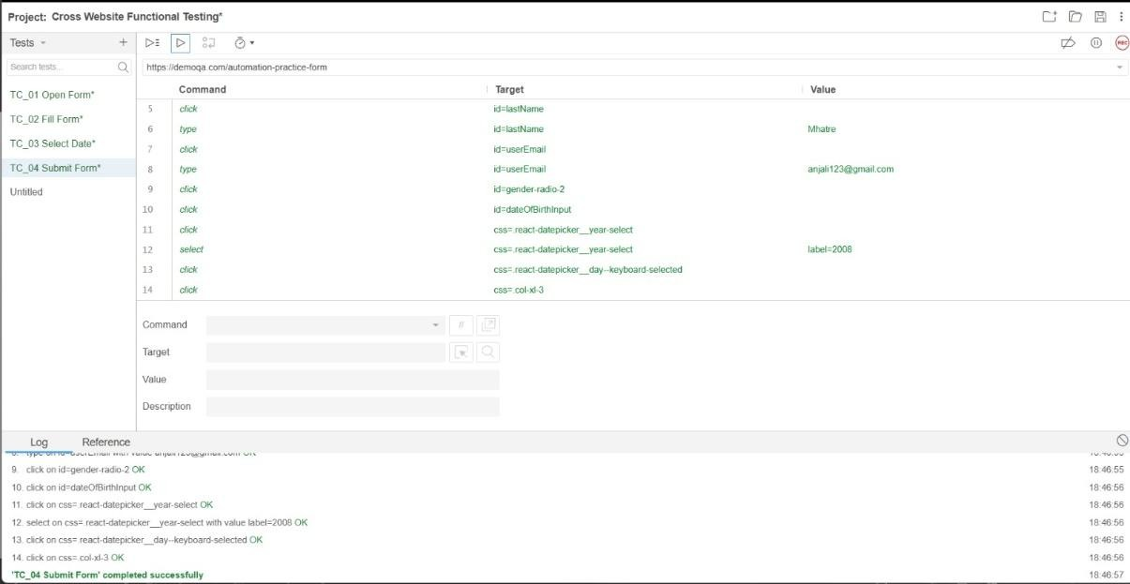

Case 5: Verify HomePage
- Open the Practice Form.
- Enter valid details in all required fields.
- Click the Submit button.
- Verify that the form is submitted successfully.
- Save the test case as TC05_VERIFY_PAGE
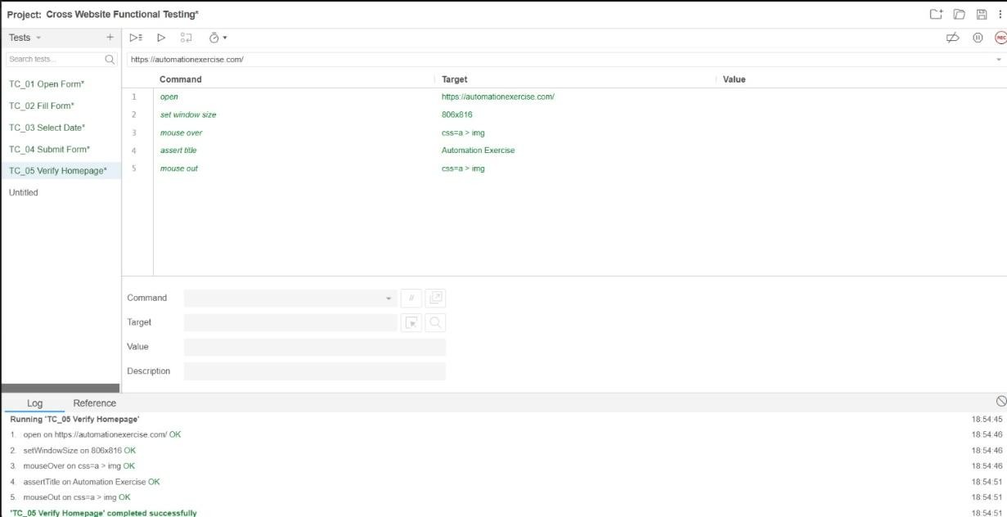

Case 6: VERIFY PRODUCTS

- Open https://automationexercise.com.
- Navigate to the Products page.
- Enter Men T-shirt in the search box.
- Click the Search button.
- Open the product details page.
- Verify that the product information is displayed correctly.
- Save the test case as Test Case 6: VERIFY_PRODUCTS
Test Case 6: VERIFY_PRODUCTS
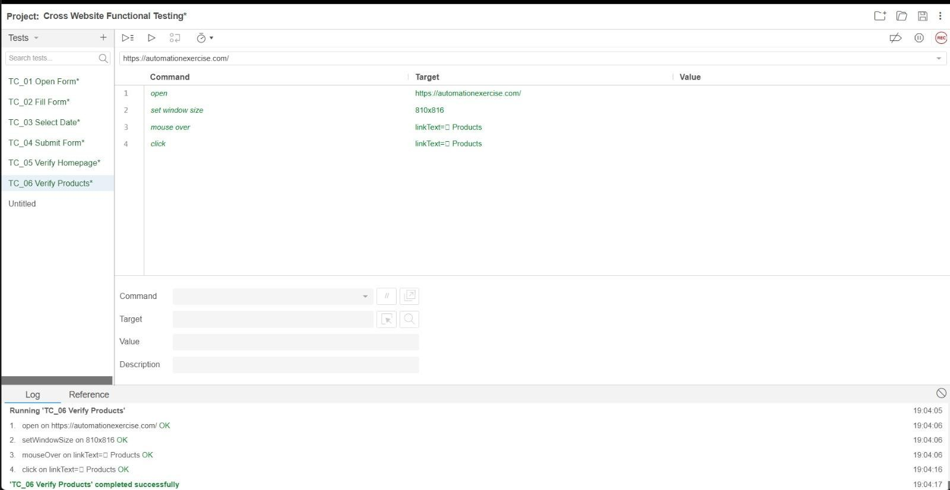

Case 7: SEARCH PRODUCTS

- Open https://automationexercise.com.
- Navigate to the Products page.
- Enter Men T-shirt in the search box.
- Click the Search button
- Search TShirt Button
- Save the Test Case 7: SEARCH_ PRODUCTS

Test Case 7: SEARCH_PRODUCTS
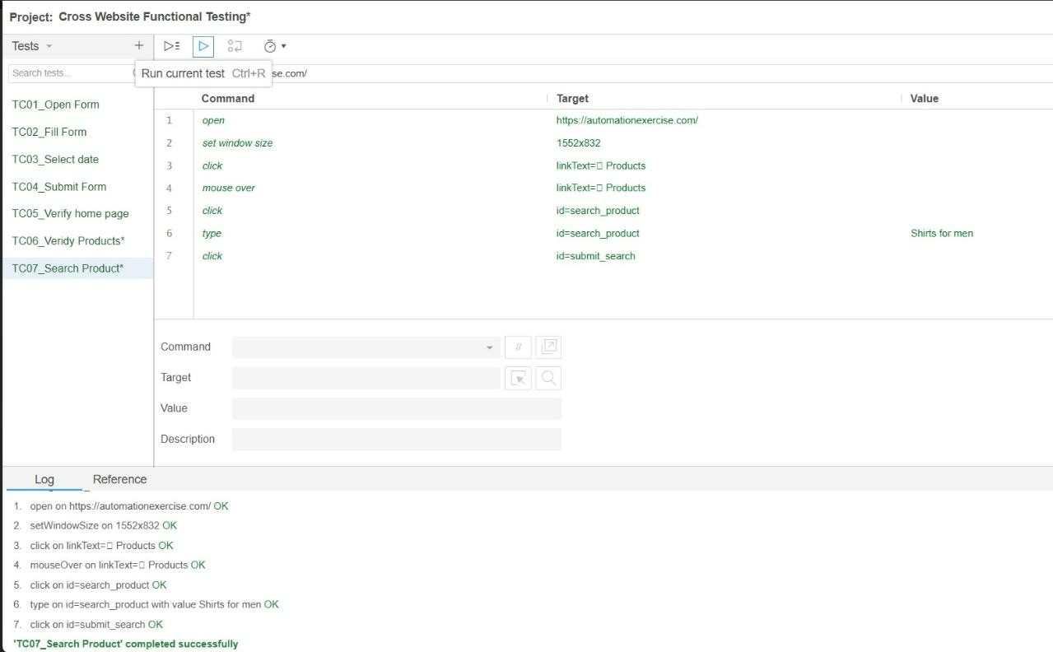

Case 8: CONTACT LINK
- Navigate to the Products page.
- Click Navigation Page
- Click the Search button
- Click Contact links
- Save Contact links Test Case 8: CONTACT_LINK

Test Case 8: CONTACT LINKS
